Machine Problem 3 (Python) Screenshots:

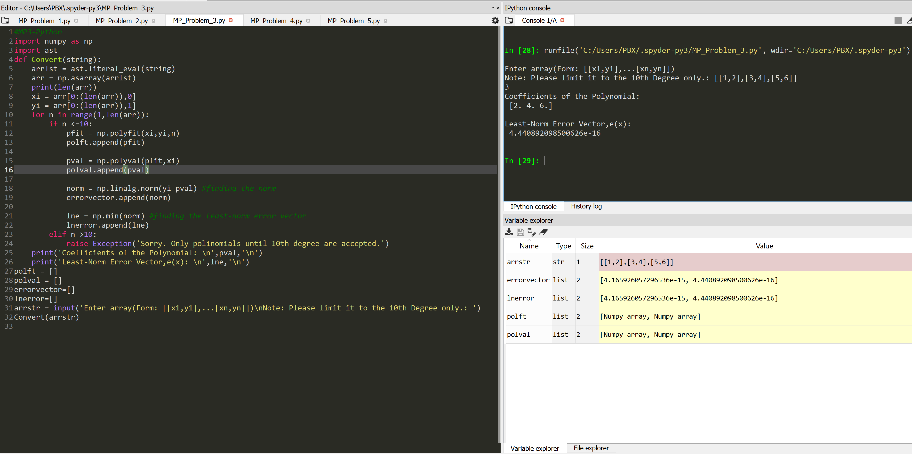

Picture 1 Code Test with 3x2 array: [[1,2],[3,4],[5,6]].

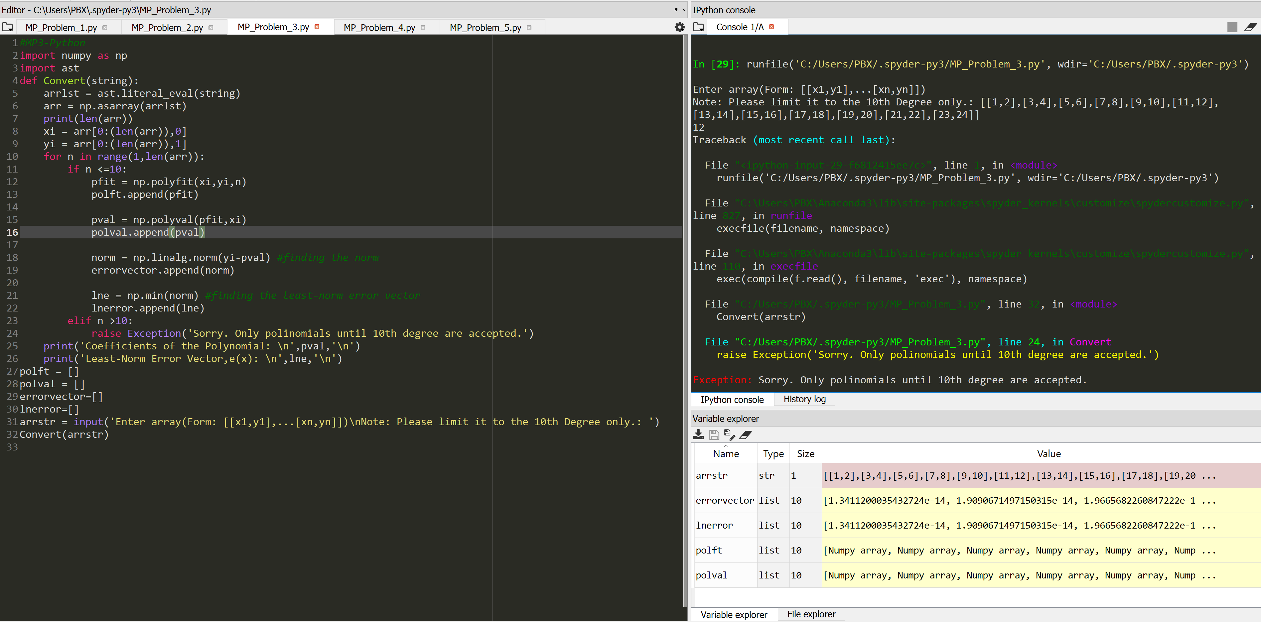

Picture 2 Error Code Test with 12x2 array:[[1,2],[3,4],[5,6],[7,8],[9,10],[11,12],[13,14],[15,16],[17,18],[19,20],[21,22],[23,24]].